Media Contact:
Betsy Carr
978-762-0500 x 202
_________
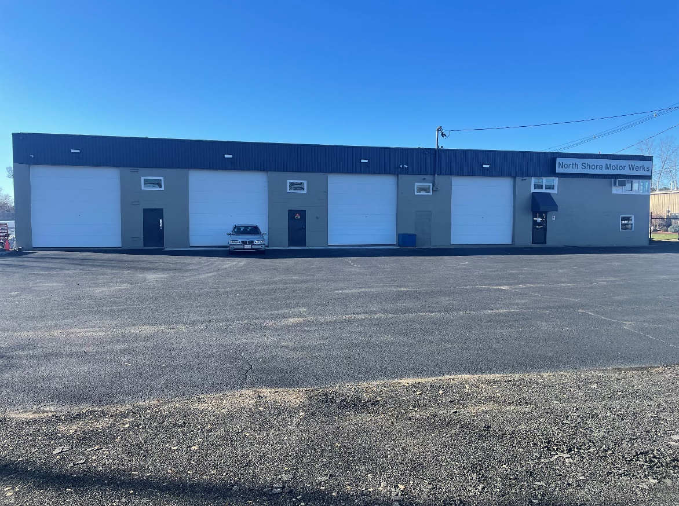
(December 12, 2022) – FOR IMMEDIATE RELEASE

Brian Triglione & Chris Everest of Nordlund Associates, Inc. Negotiate Lease at 14 Lonergan Road, Middleton, MA.

Middleton, MA – Nordlund Associates, Inc. facilitated the leasing of 14 Lonergan Road, Middleton, MA, a commercial industrial property situated on 3.5 Acres totaling +/- 7,800 SF just off Route 114. Nordlund represented the tenant (North Shore Motor Werks) and secured the property in an “Off-Market” transaction with the Landlord (14 Lonergan Road, LLC).

According to the buyer, “We engaged Chris & Brian of Nordlund to locate a property to facilitate the expansion and relocation of our company. The team worked diligently and successfully located this off-market opportunity that will allow us to continue to service our existing customer base and provide future expansion opportunity.”

North Shore Motor Werks specializes in BMW repair and maintenance. They are well equipped and highly skilled to handle most European cars, such as Porsche, Mercedes, Audi/VW.

Nordlund Associates, Inc. is a full-service commercial real estate firm serving tenants, landlords and investors by facilitating the acquisition and/or divestiture of properties through traditional and innovative strategies. We attribute our success to our knowledge, expertise, personalized service, and entrepreneurial values. Creative solutions, adjustments and decisions are made on the go.

